1. **Moodle Installation Steps :-**

**Step 1:-** Go to **moodle folder** then open **include** folder then edit **config.php** file.

See below screenshot.

**Moodle folder** **-> config.php**

1. Change **$CFG->wwwroot** http://www.rothrsolutions.com **this link replace to** our domain
2. **$CFG->dataroot** change its path to your **moodledata** folder.

**Ex.**:- /home2/rothrres/moodledata

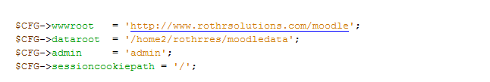

1. Change database name, username, password to our database name, username, password

